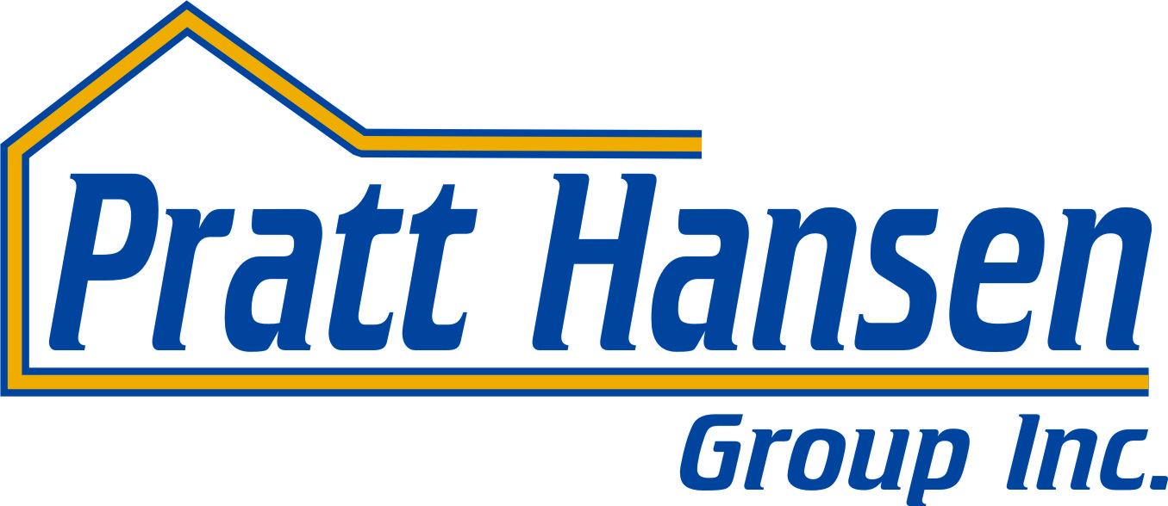

Pratt Homes Year-end Drywall Repair Policy

Even though drywall damage that is a result of normal shrinkage and drying of construction materials is not warrantable, Pratt Homes does provide our home owners with one opportunity during the first year of occupancy of the home to request repairs to shrinkage cracks and nail pops as a courtesy.
We recommend you wait until year end to make this request so that your home has been through all four seasons and has had a chance to shrink and settle.
Please be aware that these drywall repairs will not be sanded, primed or painted. This is work that should be completed by your painter.

Regards,
Pratt Hansen Group Inc
Service Department

