SCHEDULE ‘B’

Scope of Work

- The Contractor shall provide all labour, tools, and materials to do a complete siding, soffit, fascia and house wrap job as per the Owners drawings and exterior color packages.
- Contractor to supply and install fall protection to meet MOL requirements.
- Contractor to supply and install house wrap at electrical rough in to be ready for insulation inspection pass. Contractor to ensure house wrap is level, tight and properly fastened and taped for a weather proof finish prior to exterior cladding.
- Contractor to tape ainstallerll seams in house wrap with approved tape. Contractor to install 3” bitumen protection tape around all windows and doors to ensure positive flashing per detail below.
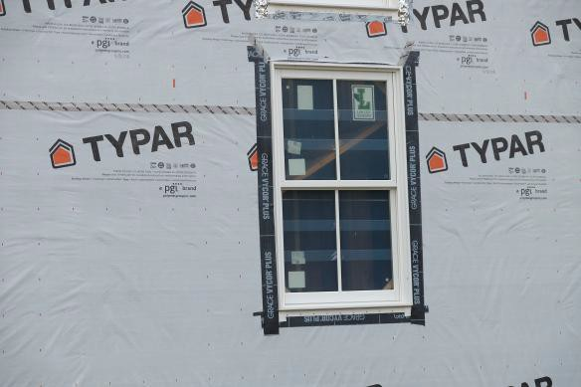

- Prior to exterior cladding Contractor to tape all penetrations in house wrap with approved tape.

- Contractor to supply and install color matched flat stock at all secondary doors. Flat stock shall be the width of the deck at patio door and width of the man door plus 3”. Flat stock must be from top of foundation to underside of door sill.
- Contractor to remove any protective coverings on windows and doors prior to applying approved tape
- Contractor to use color matching galvanized fasteners on all exposed cladding. *If available, close match is expected
- Contractor to supply and install all exterior cladding per manufacturers instructions.
- The Contractor shall warranty all work as per the requirements of the Ontario New Home Warranty Program and Tarion

- The Contractor shall remove all material and debris generated by his operation to a location as directed by the Site Superintendent. Failure to properly discard waste daily shall result in the Owner backcharging the Contractor for the costs of the clean-up.
- The Contractor shall ensure that all work performed under this Agreement is equal to or better than the requirements of the Ontario Building Code and is accepted by the City of Ottawa.
- The Contractor shall provide to the Owner, prior to starting his work, proof of a Two Million Dollar Liability Insurance naming the Contractor and the Owner jointly for the duration of the contract.

- (continued)15. Contractor to follow below detail for deck attachment to framing at 2nd floor balconies and main floor above a walkout condition.

